input parameters 1
get mean velocity profile 1
build LNS and output operators 1
build weight matrix to enforce energy norm 2
compute resolvent operator 2
SVD 2
map to [u; v; w] 2
enforce symmetry in across channel centerline 2
plot psi_1 2
plot several psi (response) modes to see the trend 2
plot several phi (forcing) modes to see the trend 3
plot singular values 3
clear
clc
% channel resolvent in velocity-vorticity formulation

input parameters
kx = 1;
kz = 12;
c = 0.667;
om = c*kx;
Re = 187;
N = 201;
Nsvd = 16;

get mean velocity profile
[y, ~, ~, ~, U0] = channelMeanVel(Re, N);
y = y(2:N-1); % for no slip BCs

build LNS and output operators
[L, C] = buildOperators(kx, kz, N, Re, U0);
ans =
7.9680e+07

build weight matrix to enforce energy norm
k2 = kx^2 + kz^2;
Q = generateWeightMatrix(N, k2);
sqrtQ = sqrtm(Q);
% invsqrtQ = inv(sqrtQ);

compute resolvent operator
I = eye(2*(N-2));
% sqrtQ = I;
% H = (-1i*om*I - L)\I;
H = sqrtQ/(-1i*om*I - L)/sqrtQ;
% H = sqrtQ*(-1i*om*I - L)*invsqrtQ;

SVD
[u, s, v] = svds(H, 20);
s = diag(s);
u = sqrtQ\u;
v = sqrtQ\v;

map to [u; v; w]
psi = C*u;
phi = C*v;

enforce symmetry in across channel centerline
[psi, phi] = channelSym(psi, phi, s, Nsvd);

plot psi_1
Ni = N-2; figure subplot(3,1,1) plot(y,real(psi(Ni+1:2*Ni,1)),'LineWidth',2) ylabel('u');xlabel('y'); subplot(3,1,2) plot(y,real(psi(1:Ni,1)),'LineWidth',2) ylabel('v');xlabel('y'); subplot(3,1,3) plot(y,real(psi(2*Ni+1:3*Ni,1)),'LineWidth',2) ylabel('w');xlabel('y');

plot several psi (response) modes to see the trend
figure
Ni = N-2;
field =0; % u = 0, v = 1, w = 2, p = 3
for i = 1:Nsvd
subplot(Nsvd/2,2,i)
plot(y, real(psi(field*Ni+1:(field+1)*Ni,i)), 'LineWidth', 2)
ylabel('v'); xlabel('y');
end
sgtitle('Response modes')
fname = sprintf('%d-%d-%d-%d-response_modes.png',Re,kx,kz,om);
set(gcf,'units','normalized','outerposition',[0 0 1 1]);
saveas(gcf,fname);
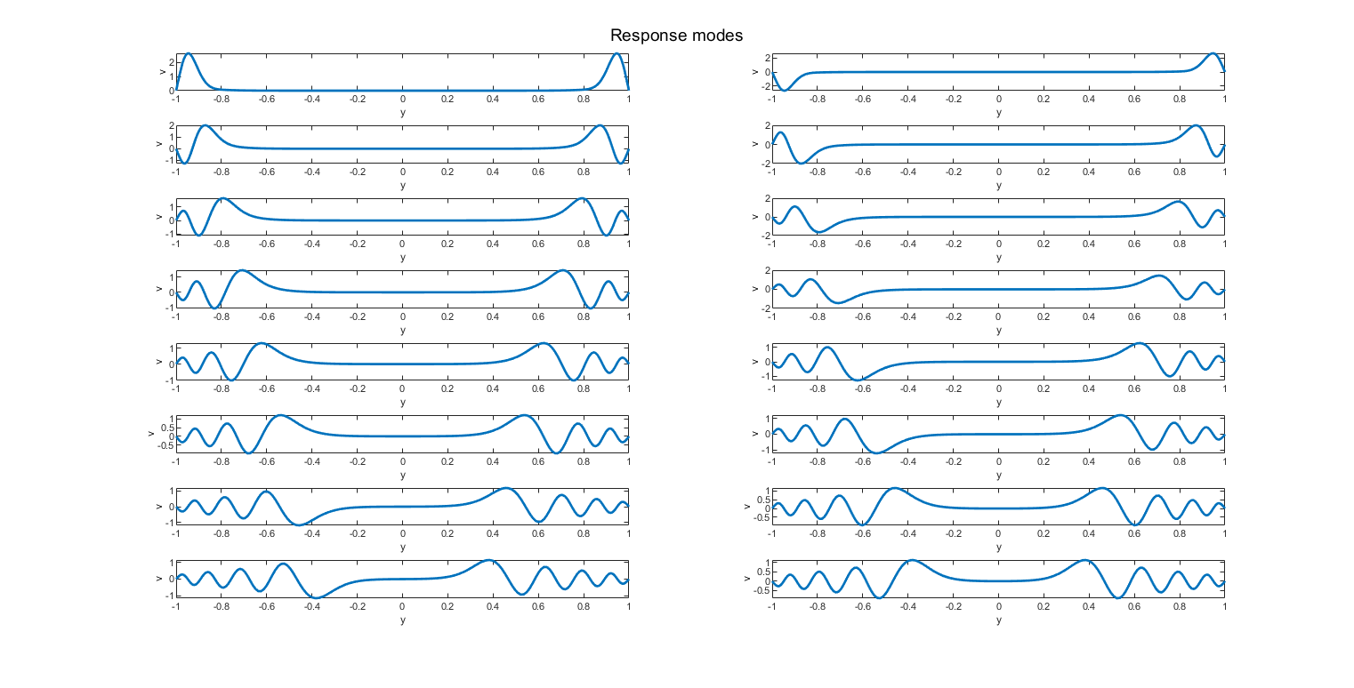

plot several phi (forcing) modes to see the trend
% figure;
% Ni = N-2;
%
% for i = 1:Nsvd
% subplot(Nsvd,1,i);
% plot(y, real(phi(1:Ni,i)), 'LineWidth', 2);
% ylabel('fv'); xlabel('y');
% end
%
% sgtitle('Forcing modes');
% fname = sprintf('%d-%d-%d-%d-forcing_modes.png',Re,kx,kz,om);
% set(gcf,'units','normalized','outerposition',[0 0 1 1]);
% saveas(gcf,fname);

plot singular values
figure
semilogy(s,'o');
ylabel('sigma'); xlabel('index');
title('Singular values (v-eta)');
fname = sprintf('%d-%d-%d-%d-singular_values.png',Re,kx,kz,om);
saveas(gcf,fname);
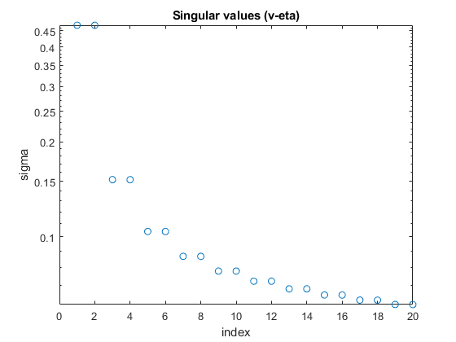
Published with MATLAB® R2021a

